**Introduction**

* What is your name and affiliation?

Ivan Sit, UCLA Undergraduate Fourth Year Student

* What is your field of research or study?

Field of study: Computer Science

**Reading habits**

* How often do you read research papers?

Three times a year – only reads when they need to

* What types of research papers do you typically engage with? (E.g., topics and contribution type)

Artificial intelligence, Math, Finance

* How do you read a paper? Do you read it through multiple times? Which section(s) do you focus on the first time, second time, etc. and why?

Read the introduction + abstract to understand the problem statement. Then, jump into how technologies/concepts are used in the paper. Likes to dive deeper into the technical components of the paper, and this is done through researching other resources that are related to the paper.

Never fully reads papers, but still does multiple scans of the sections that are important: intro, abstract, methodology

* What makes a paper easier to digest/read for you than others?

Clear headings/structure, clearly defined problem statement and well defined approach in the abstract, and graphs/visualizations to explain theoretical concepts/how certain technologies work

**Tools**

* Have you used any tools or techniques to help you read papers? Are there any tools that you wish existed that you think would help you?

ChatGPT to summarize the paper and understand the concepts behind the paper

**Notes from think aloud study**

* Participant spent first few minutes reading the abstract
* Proceeds to skim contents of the headings
* Some words in the keywords section were confusing to the user, so searched it up using chatgpt
* Appreciated how the paper outlines the research questions clearly on the first page.
* Proceeded to feed paper into ChatGPT and asked it to summarize it to 10 key points that the paper is trying to convey and what to look out for when reading the paper – said that from his experience, sometimes reading a paper without understanding the big picture is a waste of time – prefers more directed reading
* User performed a second pass on the paper based on the bullet points provided by ChatGPT
* Had trouble understanding the statistic calculations, and had to research using the internet + chatGPT to get a better understanding of what the stats are trying to tell
* 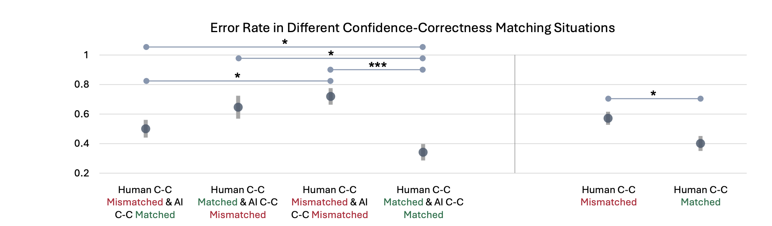
* Could not figure outwhat this diagram was truying to state, had to feed it into chat gpt again

**Process Questions**

* Which sections of a research paper do you consider most important for understanding its content?

Research questions, methodology, abstract, and headers

* When summarizing a paper, which sections provide the most useful information?

Results, graphs/visualizations, abstract

* What aspects of the summarization process do you find most challenging?

The technical part - equations and statistics. It is hard to understand the significance of it.

* Can you describe how you typically navigate through a research paper?

Already answered / asked in previous question

* Is your reading process linear, or do you follow a different pattern?

Targeted reading – from abstract, summary from ChatGPT, and initial intent, they skim paper to fins exactly what they are looking for

**Understanding the role of Data in Papers**

* What challenges do you encounter when reading data-intensive research papers?

Data, calculations, visualizations sometimes feel very scattered and hard to figure out how they connect all together

* What aspects of interpreting charts and statistical data in research papers do you find most difficult?

When encountering a new type of visualization, it is hard to interpret what the data is actually trying to show

* How do you approach understanding the “Results” or “Evaluation” sections of a paper?

Figure out what they think they have done well, and from that, go back to the sections of the paper in which they arrived there to get a better understanding of the process.

* Do you find it challenging to connect data presented in charts to real-world implications? If so, what do you think contributes to this difficulty?

To achieve this, someone has to have a lot of experience reading papers and other studies, and reading a paper in isolation makes it challenging to see the greater significance of the paper. Could be useful if papers can suggest other works/studies/papers that certain data is tied or related to.